Azure Database for MySQL - Flexible Server is a fully managed MySQL database as a service offering that can handle mission-critical workloads with predictable performance and dynamic scalability. Develop applications with Azure Database for MySQL leveraging the open-source tools and platform of your choice.

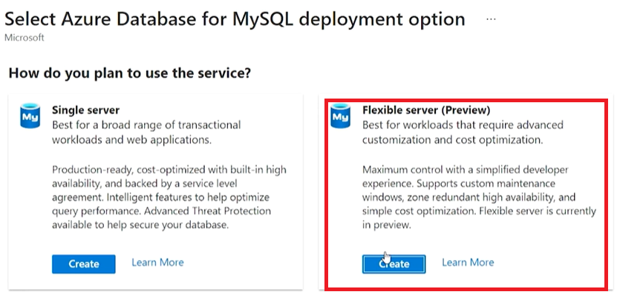

La diferencia

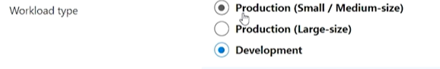



Al configurar servidor (opcion) no aparece Basic / Prefence / Memory optimization, sino que

